La Bestia de Calchín ha sido desatada
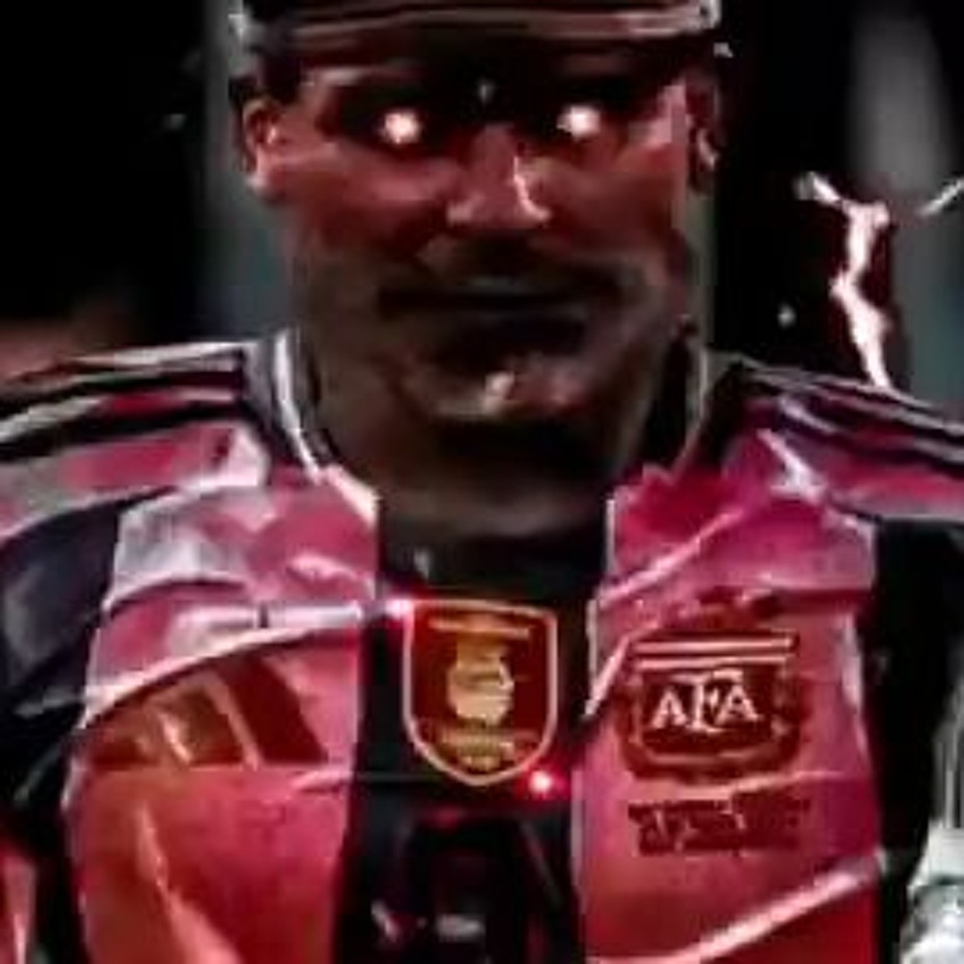
How can you see into my eyes
Like open doors?
Leading you down into my core
Where I've become so numb
Without a soul (soul)
My spirit's sleeping somewhere cold
Until you find it there and lead it back home
wake me up inside
(I can't wake up) wake me up inside
(Save me) call my name and save me from the dark
(Wake me up) bid my blood to run
(I can't wake up) before I come undone
(Save me) save me from the nothing I've become
Now that I know what I'm without
You can't just leave me (oh, oh-oh)
Breathe into me and make me real (make me real)
Bring (bring) me (me) to life
wake me up inside
(I can't wake up) wake me up inside
(Save me) call my name and save me from the dark
(Wake me up) bid my blood to run
(I can't wake up) before I come undone
(Save me) save me from the nothing I've become
Bring me to life
I've been livin' a lie
There's nothing inside
Bring me to life
Frozen inside (frozen inside)
Without your touch (without your love)
Without your love, darling
Only you (only you) are the life (life)
Among the dead
All this time, I can't believe I couldn't see
Kept in the dark, but you were there in front of me
I've been sleeping a thousand years, it seems
Got to open my eyes to everything
Without a thought, without a voice, without a soul
Don't let me die here
There must be something more
Bring me to life
wake me up inside
(I can't wake up) wake me up inside
(Save me) call my name and save me from the dark
(Wake me up) bid my blood to run
(I can't wake up) before I come undone
(Save me) save me from the nothing I've become
Bring me to life
I've been living a lie (bring me to life)
There's nothing inside (there's nothing inside)
Bring me to life

